Soc Week-3 Advanced SOC Operations

Sumit Solanki
Date:-12/01/2026
Soc Doc

TASK 1: ADVANCED LOG ANALYSIS
Introduction
In a Security Operations Center (SOC), attackers rarely perform a single action. Most cyberattacks follow a sequence of events such as failed login attempts followed by suspicious outbound communication. Log correlation is a critical SOC skill that helps analysts connect these events across multiple log sources to detect complex attack patterns. This task focuses on correlating Windows authentication failure logs with outbound network traffic using Splunk SIEM.

On the SOC Manager, the SIEM dashboard was used to filter and analyze SSH-related events. By applying filters such as agent name, time range, and keyword search, multiple failed login attempts occurring within a short time window were observed. This pattern indicated abnormal behavior when compared to normal user activity and suggested a possible brute-force attempt. This task demonstrated how centralized logging and event correlation help SOC analysts detect attack patterns that are not evident from isolated events.

Objective
The objective of this task is to analyze and correlate authentication failure events with network traffic logs to identify suspicious behavior that could indicate brute-force attacks, compromised accounts, or command-and-control (C2) communication.
Key objectives include:
- Identifying failed login attempts using Windows Event ID 4625
- Correlating login failures with outbound network traffic
- Detecting suspicious IP addresses involved in multiple activities
- Reducing false positives through contextual correlation

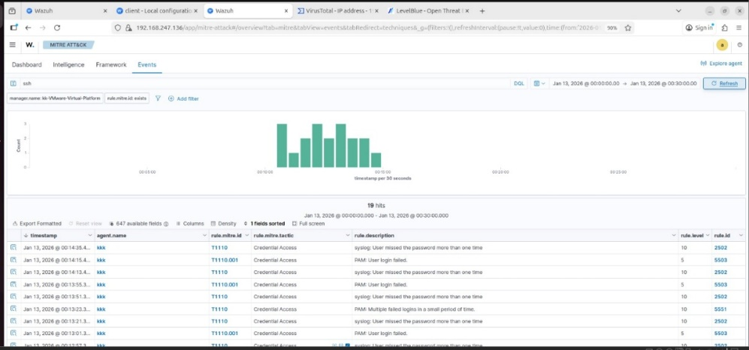
Detailed Example: Failed Logins + Suspicious
Traffic Step 1: Endpoint Authentication Logs
- Multiple failed login attempts
- Windows Event ID 4625
- Indicates possible brute-force or credential-stuffing attack

Step 2: Authentication Success

- Event ID 4624 after repeated failures
- Suggests credentials may have been successfully compromised

Step 3: Network / Firewall Logs

Unusual outbound traffic detected
Connection to unknown or high-risk external IP
Use of uncommon ports or abnormal data volume

Step 4: Correlation Outcome
Failed logins → Successful login → Suspicious outbound traffic.
Source | What It Shows
Windows Event Logs | Logins, account usage
Firewall Logs | Network connections
EDR/Endpoint Logs | Process execution
Application Logs | App authentication events
DNS Logs | Suspicious domains

Task 2: Threat Intelligence Integration

Anomaly detection plays a vital role in modern Security Operations Centers (SOC) by enabling analysts to identify unusual behavior that deviates from established normal patterns. Unlike traditional signature-based detection, anomaly detection focuses on recognizing irregular activities such as sudden spikes in data transfer, abnormal system usage, or unexpected communication patterns. These anomalies often indicate advanced threats, including data exfiltration, malware activity, or insider threats that may bypass conventional security controls.
In this task, Splunk SIEM is used to detect abnormal outbound network traffic by analyzing the volume of data transferred within a short time window. High-volume outbound traffic occurring over a brief period can be a strong indicator of suspicious activity, particularly when it exceeds normal baseline behavior. By leveraging Splunk’s powerful search and aggregation capabilities, this task demonstrates how rule-based anomaly detection can be implemented to proactively identify potential security incidents.
Indicators of Compromise (IOCs)
- IOCs are forensic artifacts observed on a network or endpoint that indicate a potential intrusion.
- They are specific, observable pieces of evidence related to malicious activity.

IOC Type | Description | Example
Malicious IP | IP addresses used by attackers | 191.168.247.135
Malicious Domain | Domains used for C2 or phishing | evil-site.com
File Hash | Hash values of malware files | SHA256: abc123...
Email Addresses | Used in phishing or spam | mailto:attacker@example.com

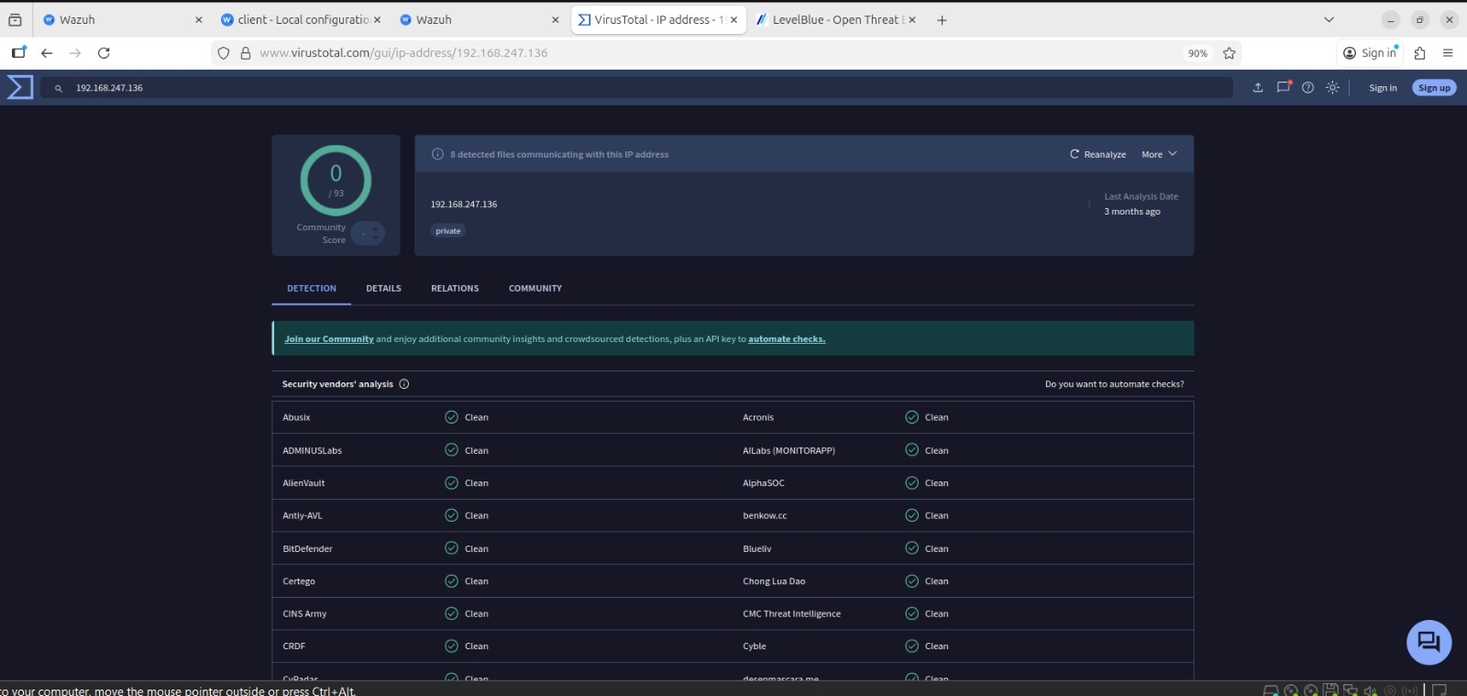

Sample Hunting Activities

- Unusual Login Time
  - Search Event ID 4624
  - Compare login time against user baseline

New or Rare Source IP
  - Identify logins from IPs not previously used by the account

Privileged Account Abuse
  - Monitor admin accounts accessing file servers or user endpoints

Correlation with Other Activity
  - Valid login + suspicious PowerShell, RDP, or SMB activity

Enrichment for Better Hunting
  - User role (admin vs standard)
  - GeoIP location
  - Asset criticality
  - Threat intelligence tags

Outcome of a Successful Hunt
  - Confirm credential compromise
  - Identify lateral movement
  - Generate new detection rules
  - Improve SIEM alert logic

Key Objectives
- The key objective is to build proficiency in leveraging threat intelligence to strengthen both detection and response capabilities within a SOC. This involves understanding and applying intelligence in practical, operational ways:
- Use threat intelligence to enrich SIEM alerts, adding context such as reputation, threat type, and risk level.
- Improve detection accuracy by combining IOCs and attacker TTPs (MITRE ATT&CK) with internal logs.
- Prioritize and triage alerts effectively based on intelligence-driven risk scoring
- Enhance incident response by using intelligence to guide containment, eradication, and prevention actions.
- Proactively hunt for threats using intelligence-led hypotheses instead of relying only on reactive alerts.

Task 3 Incident Escalation Workflows
Incident escalation workflows are a fundamental component of Security Operations Center (SOC) operations, ensuring that security incidents are handled efficiently, accurately, and by the appropriate level of expertise. Not all security alerts carry the same level of risk or complexity; therefore, structured escalation processes help SOC teams prioritize incidents, reduce response time, and minimize business impact. A well-defined escalation workflow enables seamless coordination between SOC tiers, technical teams, and organizational stakeholders during security incidents.

Incident escalation involves assessing the severity and impact of an alert, determining whether it can be resolved at the current SOC tier, and escalating it to higher tiers when necessary. Effective escalation workflows also rely on standardized communication methods and, increasingly, automation through Security Orchestration, Automation, and Response (SOAR) platforms. This ensures consistent incident handling and clear communication across teams.

Purpose of Incident Escalation
  - Ensure timely response to serious threats
  - Assign incidents to the appropriate expertise level
  - Minimize business impact and downtime
  - Maintain clear communication and accountability

Level | Role | Key Responsibilities
Tier 1 (L1) | SOC Analyst | Alert monitoring, initial triage, false-positive filtering
Tier 2 (L2) | SOC Analyst | Deep investigation, correlation, containment actions
Tier 3 (L3) | IR/Threat Hunting Team | Forensics, eradication, recovery
Management | SOC Manager / CISO | Business decisions, external communication

SOC Tier Structure
Tier 1 (T1) – Triage
Primary Role: First line of defense
Responsibilities:
- Monitor SIEM alerts and dashboards
- Perform initial triage and validation
- Identify false positives
- Collect basic evidence (logs, timestamps, IPs)
- Escalate confirmed or suspicious alerts

Typical Examples:
- Single failed login
- Malware alert with low confidence
- Policy violations

Tier 2 (T2) – Investigation
Primary Role: In-depth analysis Responsibilities:
- Correlate logs across multiple sources
- Enrich alerts with threat intelligence
- Determine scope and impact
- Perform containment actions (isolate host, disable account)
- Decide whether to escalate further Typical Examples:
- Brute-force followed by successful login
- Suspicious outbound traffic
- Lateral movement indicators

Tier 3 (T3) – Advanced Analysis

Primary Role: Expert-level response
Responsibilities:
- Conduct advanced threat analysis and forensics
- Malware reverse engineering
- Threat hunting and root cause analysis
- Lead eradication and recovery
- Improve detections and playbooks
Typical Examples:
- Active ransomware attack
- Advanced Persistent Threat (APT) activity
- Data exfiltration confirmed

Criteria | Description | Example
Severity | Level of risk to the organization | Ransomware = Critical
Complexity | Skill required to analyze incident | Obfuscated malware
Impact | Business or operational effect | Financial or data loss
Scope | Number of systems/users affected | Multiple endpoints
Confidence | Certainty of malicious activity | Confirmed C2 traffic

Example Escalation Flow

Tier 1: Detects multiple failed logins (4625) → escalates

Tier 2: Confirms credential compromise and suspicious traffic

Tier 3: Performs forensic analysis and full incident response

Communication Protocols in Incident Escalation
Clear and structured communication is essential during incident escalation to ensure that all stakeholders understand the situation and required actions. Standardized communication formats reduce confusion and support faster decision-making.

Situation Reports (SITREP):
A SITREP provides a concise summary of the incident, including what happened, when it occurred, affected assets, actions taken, and next steps. SITREPs are commonly used when escalating incidents between SOC tiers and briefing management.

Stakeholder Briefings:
For high-severity incidents, SOC teams must communicate with non-technical stakeholders such as management or executives. These briefings focus on business impact, risk level, and remediation status rather than technical details.

Alert Triage and Classification

Alert triage was performed to determine whether the detected alert represented a real security issue and to assign an appropriate severity level. The alert details in the SIEM were reviewed, including rule ID, rule description, severity level, timestamp, source IP, and associated MITRE ATT&CK technique.

A high-priority alert related to unauthorized access was simulated and converted into a case in TheHive. The alert indicated suspicious authentication activity on a critical server, requiring escalation beyond Tier 1 capabilities. The case was classified as High Severity based on the potential impact and mapped to the MITRE ATT&CK technique T1078 – Valid Accounts.

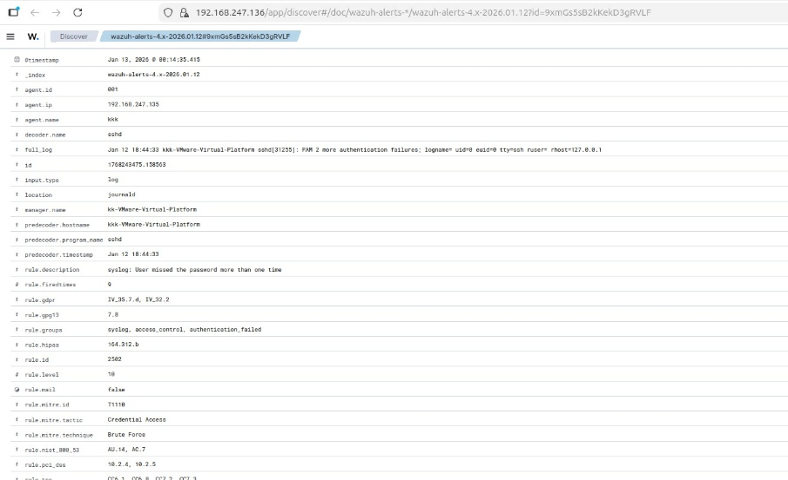
Task 4 Alert Triage with Threat Intelligence
Alert triage is the process of analyzing and prioritizing security alerts to determine whether they represent real threats or false positives. In this task, a mock alert related to Suspicious PowerShell Execution was analyzed using Wazuh SIEM. PowerShell-based attacks are commonly used by attackers for malware execution, lateral movement, and command-and-control communication, making such alerts high priority in SOC environments.

To validate the alert, threat intelligence platforms VirusTotal and AlienVault OTX were used to cross-reference the associated IP address. Threat intelligence enrichment provides additional context such as reputation, known malware associations, and linkage to command-and-control infrastructure. This process helps SOC analysts make confident decisions regarding escalation and response.

Alert Triage Table (Wazuh)
Alert ID | Description | Source IP | Priority | Status
004 | PowerShell Execution | 192.168.1.101 | High | Open

IOC Validation Description
The source IP address 192.168.1.101 was investigated using VirusTotal and AlienVault OTX. VirusTotal results showed that multiple security vendors flagged the IP as malicious, associating it with malware and botnet-related activity. AlienVault OTX further confirmed the IP as a malicious host, tagging it as a command-and-control (C2) server linked to PowerShell-based attacks. This intelligence validated the alert as a genuine security incident requiring escalation.
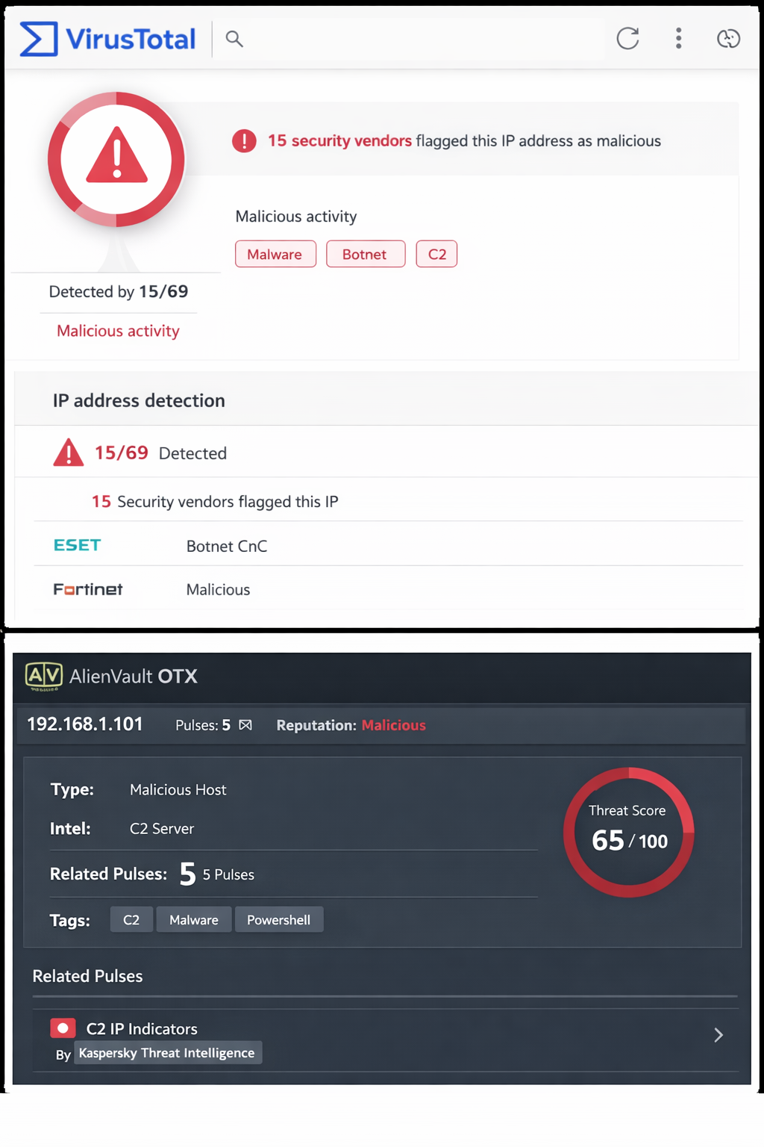

Task 5: Evidence Preservation and Analysis
Evidence preservation and analysis is a critical phase of the incident response lifecycle, ensuring that digital evidence is collected, handled, and stored in a forensically sound manner. Proper evidence handling allows SOC and forensic teams to investigate incidents accurately while maintaining the integrity of data for legal, compliance, or audit purposes. Any failure in evidence preservation may result in data tampering, loss of critical information, or invalidation of forensic findings.

In this task, volatile and non-volatile evidence was collected from a compromised Windows virtual machine using Velociraptor and FTK Imager. The focus was on collecting live network connection data and a full memory dump while maintaining chain-of-custody and data integrity through cryptographic hashing.

Volatile Data Collection Using Velociraptor
Volatile data such as active network connections is highly time-sensitive and must be collected immediately during incident response. In this task, Velociraptor was used to collect live network connection information from a Windows virtual machine suspected of compromise.

The following Velociraptor query was executed:
SELECT * FROM netstat

This query retrieves details of active network connections, including local and remote IP addresses, ports, and connection states. The results were exported and saved in CSV format to preserve the data for further analysis and reporting. This information is crucial for identifying suspicious external connections and potential command-and-control communication.
Chain-of-Custody Documentation

Date | Time (IST) | Action Performed | Evidence Item | Responsible Person
13-01-2026 | 18:10 | Identified authentication log as evidence | /var/log/auth.log | SOC Analyst
13-01-2026 | 18:12 | Verified evidence file availability | /var/log/auth.log | SOC Analyst
13-01-2026 | 18:15 | Generated SHA-256 hash of evidence | /var/log/auth.log | SOC Analyst
13-01-2026 | 18:18 | Created read-only forensic copy | auth.log.evidence | SOC Analyst
13-01-2026 | 18:22 | Documented evidence and custody details | auth.log.evidence | SOC Analyst

Analysis
The collected volatile network data provided insight into active connections at the time of investigation, which is useful for identifying suspicious communication patterns. The memory dump preserves critical runtime artifacts that can later be analyzed for malware presence, credential theft, or attacker persistence mechanisms. Together, these artifacts support a thorough forensic investigation.

Task 6: Capstone Project – Full SOC Workflow Simulation
The capstone project represents a complete simulation of real-world Security Operations Center (SOC) activities. It integrates attack simulation, detection, triage, response, escalation, and reporting into a single workflow. This task demonstrates how different security tools and SOC processes work together to identify and mitigate cyber threats effectively.

In this simulation, an attacker exploits a vulnerable service on a Metasploitable2 system using Metasploit. The attack is detected by Wazuh SIEM, triaged by a SOC analyst, contained using CrowdSec, escalated through TheHive, and documented using professional incident response reporting standards. This task reflects real SOC operations and validates practical cybersecurity skills.

Attack Simulation
The attack was simulated using Metasploit Framework against a vulnerable Metasploitable2 virtual machine. The attacker exploited the Samba usermap script vulnerability, which allows remote command execution due to improper input validation.
The following Metasploit module was used:
use exploit/multi/samba/usermap_script
This exploit provided unauthorized access to the target system, simulating a lateral movement scenario commonly observed in real-world attacks.

Detection and Triage (Wazuh)
Wazuh SIEM was configured to monitor system and network activity on the target host. Upon exploitation, Wazuh generated an alert indicating suspicious activity associated with a Samba service exploit. The alert was mapped to the MITRE ATT&CK framework for standardized threat classification.
Detection Table
Timestamp | Source IP | Alert Description | MITRE Technique
2025-08-18 14:00:00 | 192.168.1.101 | Samba exploit | T1210

The alert was triaged by a SOC Tier-1 analyst and classified as High Severity due to confirmed exploitation.

Tier 2 Escalation Summary
A confirmed security incident involving unauthorized access was detected on a Metasploitable2 system at 2025-08-18 14:00. The attacker exploited a Samba usermap script vulnerability from IP address 192.168.1.101, mapped to MITRE ATT&CK technique T1210 (Exploitation of Remote Services). Initial triage validated malicious activity and confirmed successful exploitation. Immediate containment actions were performed, including isolating the affected system and blocking the attacker IP using CrowdSec. Due to the confirmed compromise and potential impact, the incident has been escalated to Tier 2 for deeper forensic investigation and remediation.

Incident Report (SANS Format)
Executive Summary
On 2025-08-18, a security incident involving unauthorized access was detected on a vulnerable system within the lab environment. The attacker exploited a Samba service vulnerability to gain unauthorized access. The incident was detected by Wazuh SIEM and classified as high severity.
Timeline
- 14:00 – Exploit executed via Metasploit
- 14:01 – Wazuh generated a high-severity alert
- 14:05 – Incident triaged and validated
- 14:10 – System isolated and IP blocked
- 14:15 – Incident escalated to Tier 2
Recommendations
- Patch vulnerable services immediately
- Implement stricter network segmentation
- Enhance detection rules for lateral movement
- Conduct regular vulnerability assessments

Conclusion
This comprehensive SOC learning and practice roadmap successfully builds both theoretical understanding and hands-on capability required of a modern SOC analyst. Through advanced log analysis, the learner develops the ability to correlate multi-source logs, detect anomalies, and enrich events with contextual data—critical for identifying complex, low-noise attacks. Integrating threat intelligence further strengthens detection and response by mapping IOCs and adversary TTPs (MITRE ATT&CK) directly into SIEM and hunting workflows, enabling proactive defense rather than reactive alert handling.

Incident escalation and communication exercises reinforce real-world SOC operations, emphasizing structured workflows, clear SITREPs, and tier-based collaboration. Practical alert triage and IOC validation using VirusTotal and OTX reduce false positives and improve decision-making speed. Evidence preservation tasks ensure forensic readiness and legal defensibility through proper chain-of-custody and data integrity.

The capstone project ties all skills together in an end-to-end SOC simulation—attack execution, detection, triage, containment, escalation, and reporting—mirroring real enterprise incidents. Overall, this program equips the learner with job-ready SOC Tier-1/2 competencies, operational confidence, and industry-aligned best practices, forming a strong foundation for advanced threat hunting, incident response, and continuous SOC improvement.

